Driver safety System – Project overview

# Scope

This project is a vehicle-based system, that helps the driver/ passengers in case of an accident. The system will analyse the motion of the vehicle and detect any accident. Incase of the driver has passed out because of an accident, this system will automatically call nearby hospital and the police.

# Technology

The sensor we decided to use is a module that consists of three-axis accelerometer, three-axis gyroscope. This helps us to measure acceleration, velocity and orientation. With this module installed we can get the motion value of the car.

MPU 6050

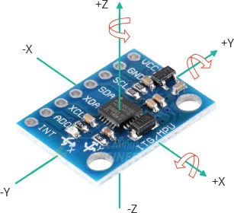.

As an example, if the acceleration is suddenly changed than normal, it must be a collision. We can also get the orientation of the car and measure whether the car is flipped or not.

We can get these measurements through a microcontroller (Arduino/ Raspberry-Pie: TBD) and integrate with other devices such as car dashboard Head up display and a smart phone.

After getting these measurements it needs to get current location of the car. In this demo build of the system we decided to use a mobile phone to get GPS data. Depend on the efficiency of the Mobile phone GPS, we will change it to a GPS module.

NEO6MV2 GPS module

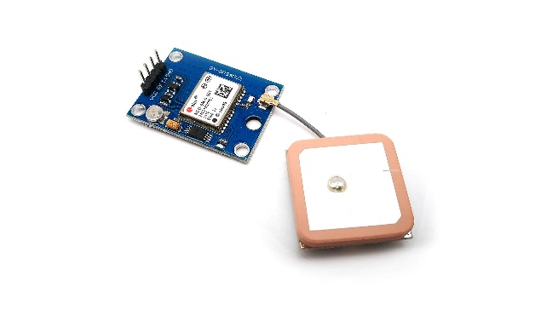 .

# Deliverables

* External device that contains the sensors and microcontroller.
* A GUI for the car dashboard display to communicate with the driver (C#/ Python: TBD).
* Mobile application for the driver to monitor the vehicle incase of a collision happen when the driver is not around.